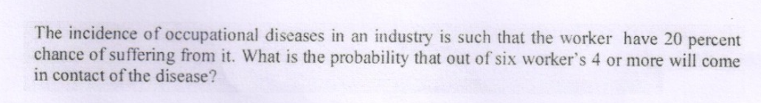
P=0.2


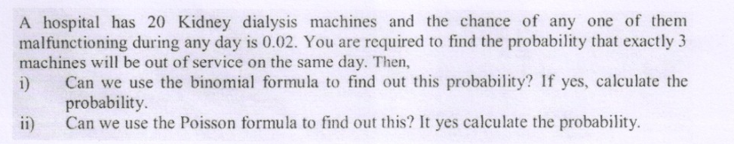
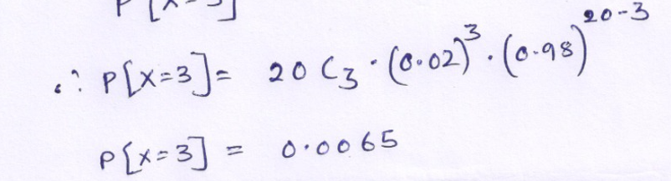
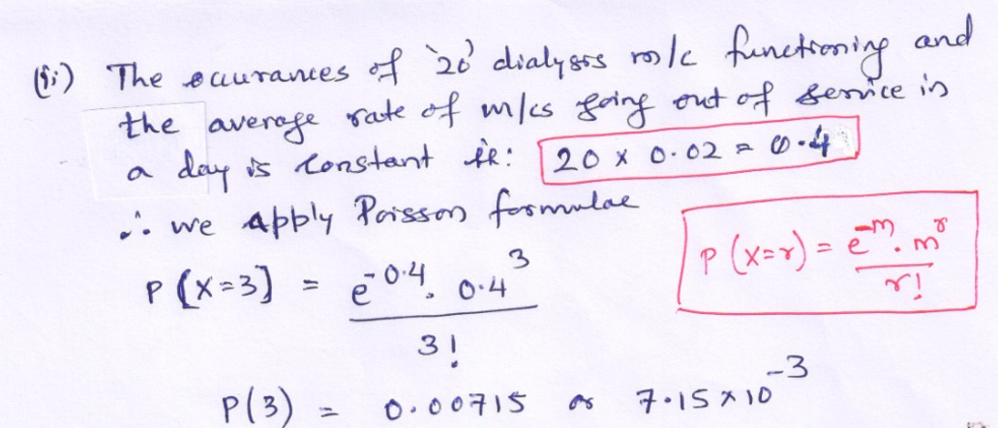
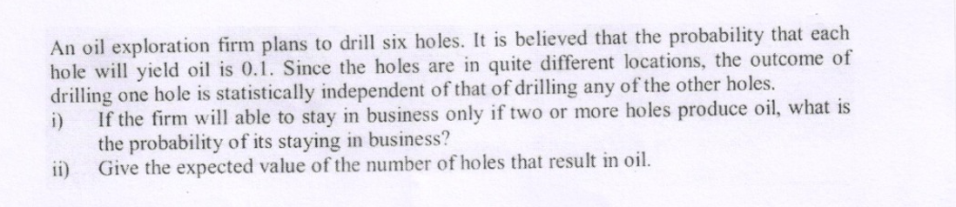

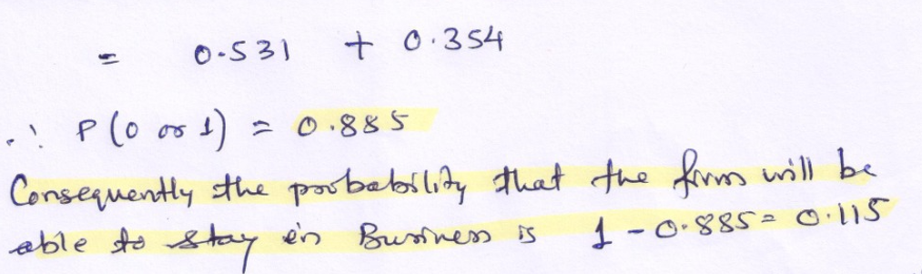

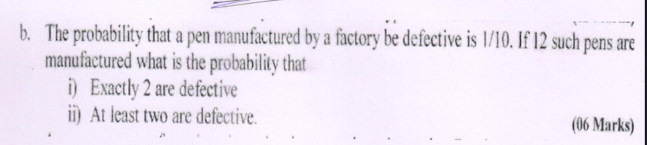

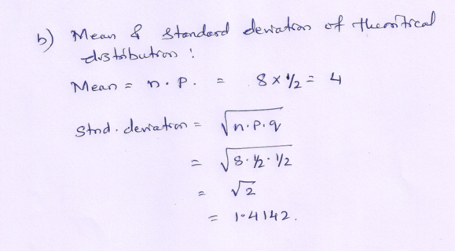

1. Coin Toss
Outcomes: {Head, Tail} → 2 possible outcomes. Favorable outcome: Head → 1. Probability = 1/2.
2. Dice Roll
Outcomes: {1, 2, 3, 4, 5, 6} → 6 possible outcomes. Favorable outcomes: {5, 6} → 2. Probability = 2/6 = 1/3.
3. Picking a Ball Total balls = 5. Favorable outcomes (red) = 3. Probability = 3/5.
4. Playing Cards Total cards = 52. Kings = 4. Probability = 4/52 = 1/13.
5. Weather Forecast Probability of rain = 0.7. Probability of no rain = 1 - 0.7 = 0.3.
Probability = 0.3 (30%).
6. Two Coin Tosses Outcomes: {HH, HT, TH, TT} → 4 possible outcomes.
Favorable outcomes = {HT, TH} → Probability = 2/4 = 1/2.
7. Rolling Two Dice Total outcomes = 36. Favorable outcomes for sum = 7 → 6.
Probability = 6/36 = 1/6.
8. Classroom Example
Total students = 30. Girls = 12.
Probability of girls = 12/30 = 2/5.
9. Lottery Ticket
Total tickets = 100. Winning tickets = 1.
Probability = 1/100.
10. Traffic Light
Outcomes: {Red, Yellow, Green} → 3 possible outcomes.
Favorable outcome = Green → 1.
Probability = 1/3.

Probability = (Number of favorable outcomes) ÷ (Total outcomes).
It helps us measure uncertainty and predict chances in everyday life.

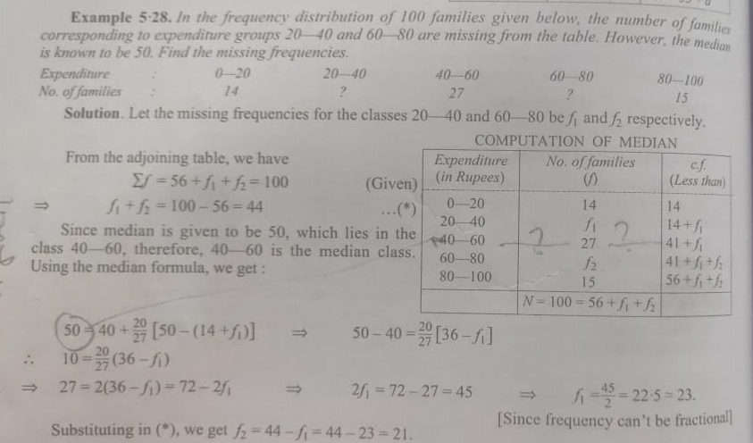
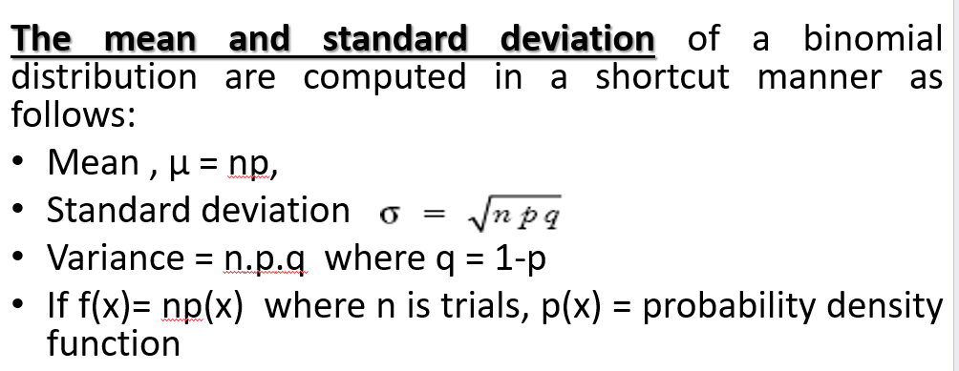

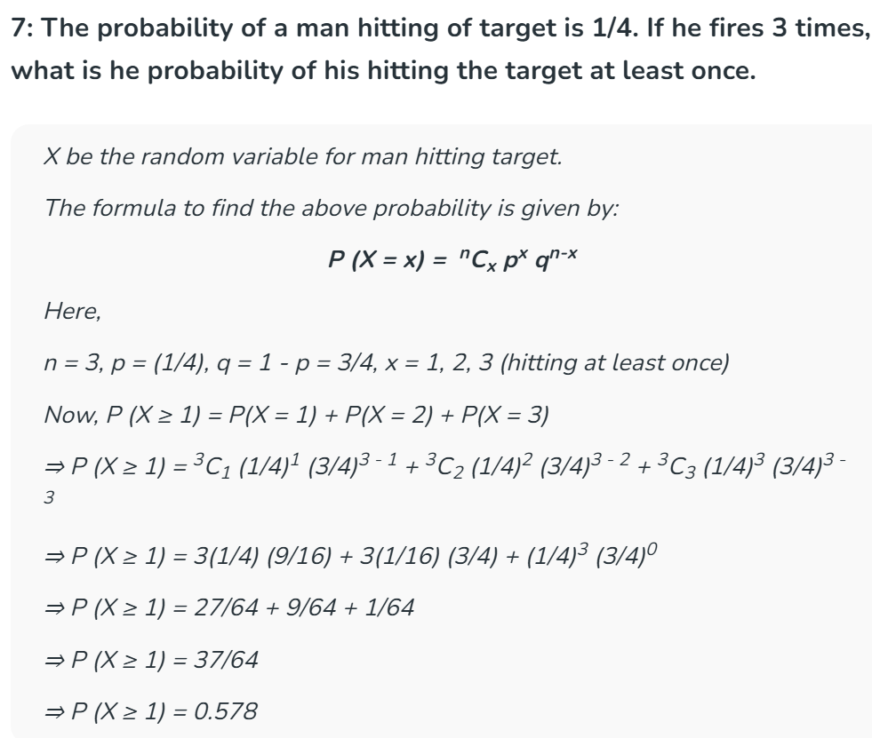
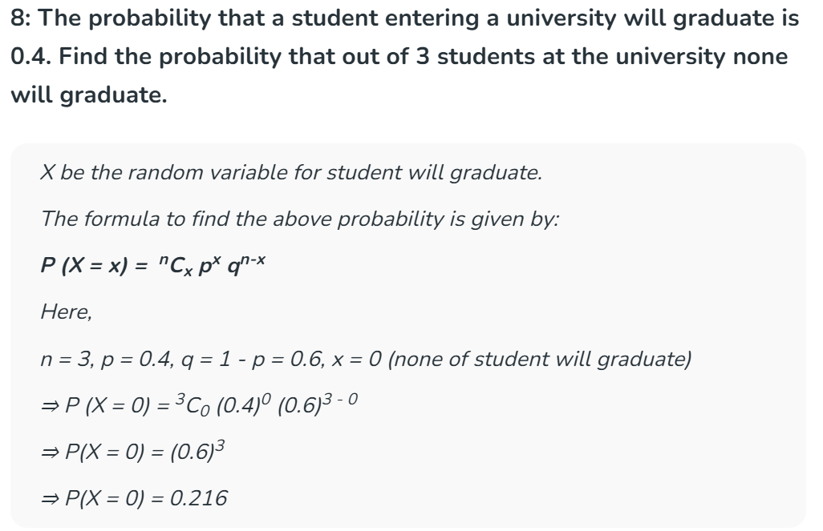

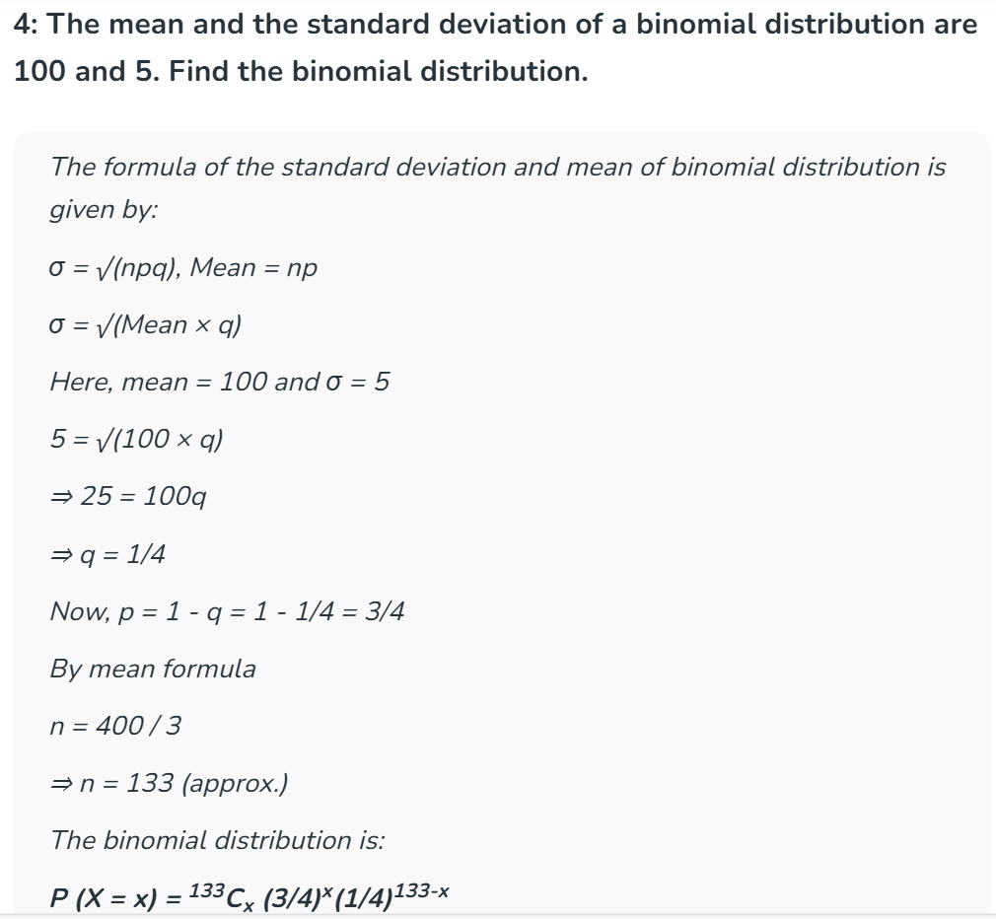

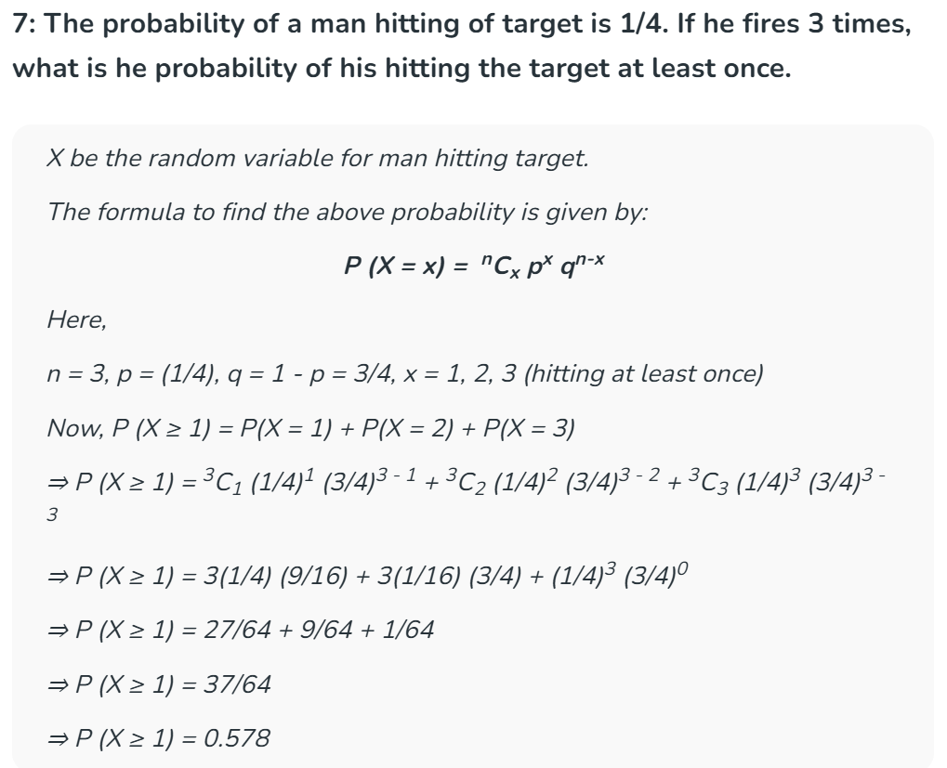

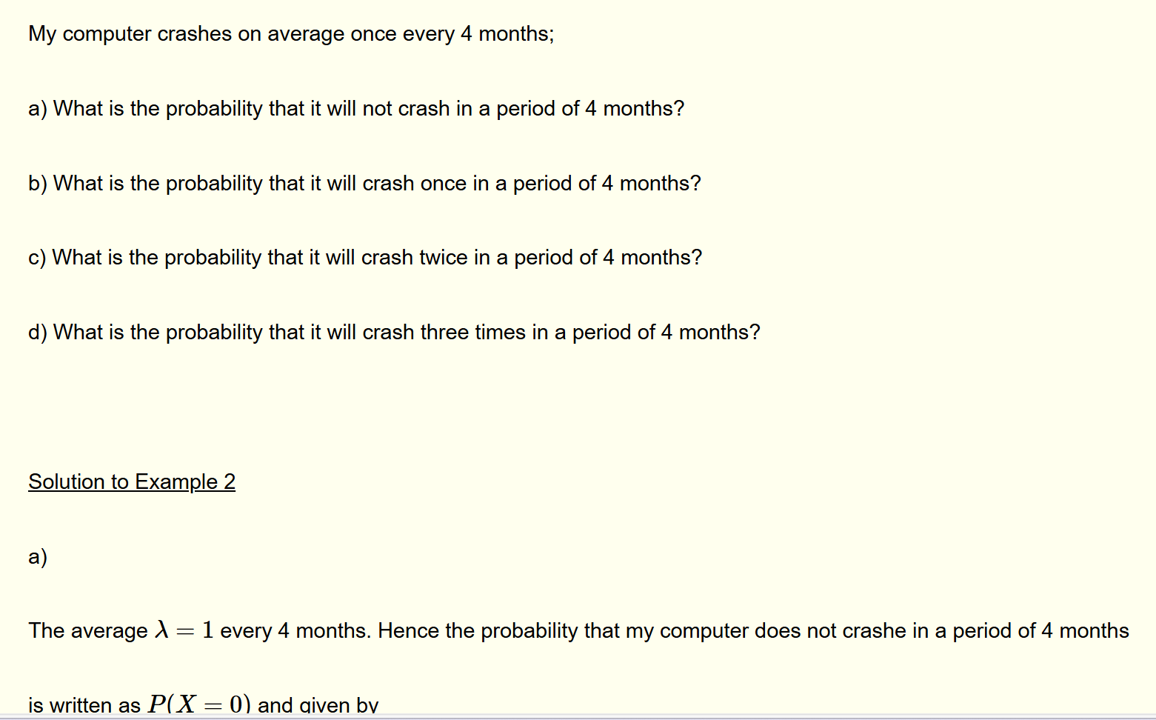

Poisson Probability distribution Examples and Questions
Poisson probability distribution is used in situations where events occur randomly and independently a number of times on average during an interval of time or space. The random variable X associated with a Poisson process is discrete and therefore the Poisson distribution is discrete.
Poisson Process Examples and Formula
Example 1
These are examples of events that may be described as Poisson processes:
- My computer crashes on average once every 4 months.
- Hospital emergencies receive on average 5 very serious cases every 24 hours.
- The number of cars passing through a point, on a small road, is on average 4 cars every 30 minutes.
- I receive on average 10 e-mails every 2 hours.
- Customers make on average 10 calls every hour to the customer help center
Conditions for a Poisson distribution are
1) Events are discrete, random and independent of each other.
2) The average number of times of occurrence of the event is constant over the same period of time.
3) Probabilities of occurrence of event over fixed intervals of time are equal.
4) Two events cannot occur at the same time; they are mutually exclusive.
Compare Binomial and Poisson Distributions
A binomial distribution has two parameters: the number of trials n and the probability of success p at each trial while a Poisson distribution has one parameter which is the average number of times λ that the event occur over a fixed period of time.
In the binomial distribution x is an integer taking values over the interval [0,n] , while in the Poisson distribution x is an integer taking values over the interval [0,∞)
Poisson distribution Examples with Detailed Solutions
The best way to explain the formula for the Poisson distribution is to solve the following example.
Example 2
My computer crashes on average once every 4 months;
a) What is the probability that it will not crash in a period of 4 months?
b) What is the probability that it will crash once in a period of 4 months?
c) What is the probability that it will crash twice in a period of 4 months?
d) What is the probability that it will crash three times in a period of 4 months?
Solution to Example 2
a)
The average λ=1 every 4 months. Hence the probability that my computer does not crashe in a period of 4 months is written as P(X=0) and given by
P(X=0)=e−λλxx!=e−1100!=0.36787
b)
The average λ=1 every 4 months. Hence the probability that my computer crashes once in a period of 4 months is written as P(X=1) and given by
P(X=1)=e−λλxx!=e−1111!=0.36787
c)
P(X=2)=e−λλxx!=e−1122!=0.18393
d)
P(X=3)=e−λλxx!=e−1133!=0.06131

Example 3
A customer help center receives on average 3.5 calls every hour.
a) What is the probability that it will receive at most 4 calls every hour?
b) What is the probability that it will receive at least 5 calls every hour?
Solution to Example 3
a)
at most 4 calls means no calls, 1 call, 2 calls, 3 calls or 4 calls.
P(X≤4)=P(X=0orX=1orX=2orX=3orX=4)
=P(X=0)+P(X=1)+P(X=2)+P(X=3)+P(X=4)
=e−3.53.500!+e−3.53.511!+e−3.53.522!+e−3.53.533!+e−3.53.544!+
=0.03020+0.10569+0.18496+0.21579+0.18881=0.72545
b)
At least 5 class means 5 calls or 6 calls or 7 calls or 8 calls, ... which may be written as x≥5
P(X≥5)=P(X=5orX=6orX=7orX=8...)
The above has an infinite number of terms. The probability of the complement may be used as follows
P(X≥5)=P(X=5orX=6orX=7...)=1−P(X≤4)
P(X≤4) was already computed above. Hence
P(X≥5)=1−P(X≤4)=1−0.7254=0.2746

Example 4
A person receives on average 3 e-mails per hour.
a) What is the probability that he will receive 5 e-mails over a period two hours?
a) What is the probability that he will receive more than 2 e-mails over a period two hours?
Solution to Example 4
a)
We are given the average per hour but we asked to find probabilities over a period of two hours. We therefore need to find the average λ over a period of two hours.
λ=3×2=6 e-mails over 2 hours
The probability that he will receive 5 e-mails over a period two hours is given by the Poisson probability formula
P(X=5)=e−λλxx!=e−6655!=0.16062
b)
More than 2 e-mails means 3 e-mails or 4 e-mails or 5 e-mails ....
P(X>2)=P(X=3orX=4orX=5...)
Using the complement
=1−P(X≤2)
=1−(P(X=0)+P(X=1)+P(X=2))
Substitute by formulas
=1−(e−6600!+e−6611!+e−6622!)
=1−(0.00248+0.01487+0.04462)
=0.93803

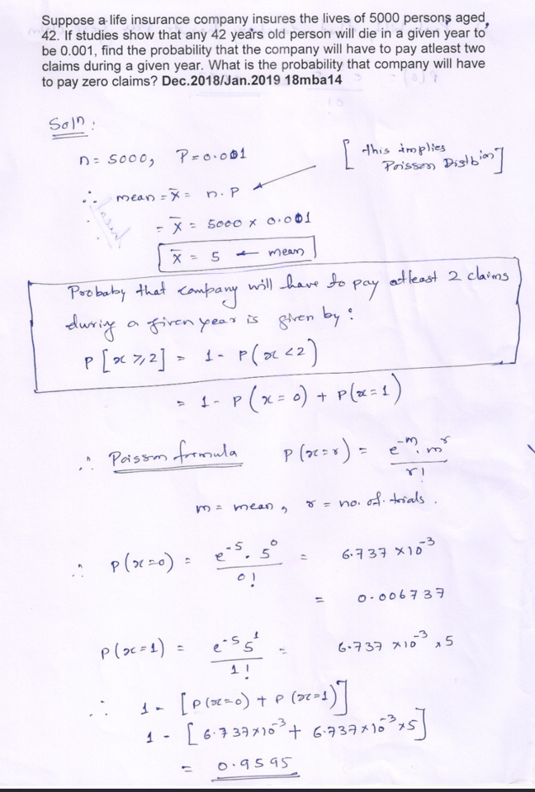
Example 5
The frequency table of the goals scored by a football player in each of his first 35 matches of the seasons is shown below.
Goals Scored , x | 0 | 1 | 2 | 3 | > 3
Frequency (Matches) , f | 12 | 15 | 6 | 2 | 0
Assuming that the goals scored may be approximated by a Poisson distribution, find the probability that the player scores
a) one goal in a given match
b) at least one goal in a given match
Solution to Example 5
a)
We first calculate the mean λ
λ=Σf⋅x/Σf=12⋅0+15⋅1+6⋅2+2⋅312+15+6+2≈33/35 = 0.94
The probability that he will score one goal in a match is given by the Poisson probability formula
P(X=1)=e−λλxx!=e−0.940.9411!=0.36719
b)
Al least one goal means 1 or 2 or 3 or 4 .... goals
P(X≥1)=P(X=1orX=2orX=3...)
Using the complement
=1−P(X=0)
Substitute by formulas
=1−e−0.940.9400!
=1−0.39062
=0.60938

Example 6
The number of defective items returned each day, over a period of 100 days, to a shop is shown below.
Number of Defective Items, x | 0 | 1 | 2 | 3 | 4 | > 4
Frequency (days) , f | 50 | 20 | 15 | 10 | 5 | 0
Assuming that the number of defective items may be approximated by a Poisson distribution, find the probability that
a) no defective item is returned on a given day
b) three or more defective items are returned on a given day
Solution to Example 6
a)
We first calculate the mean λ
λ=Σf⋅xΣf=50⋅0+20⋅1+15⋅2+10⋅3+5⋅450+20+15+10+5=1
The probability that no defective item is returned is given by the Poisson probability formula
P(X=0)=e−λλxx!=e−1100!=0.36787
b)
At least three or more defective items are returned means 3 or 4 or 5 .... itmes or x≥3
P(X≥3)=P(X=3orX=4orX=5...)
Using the complement
=1−P(X=0orX=1orX=2)
Use the sum formula of probabilities and Poisson by formula
=1−(e−1100!+e−1111!+e−1122!)
=1−0.91969
=0.08031

